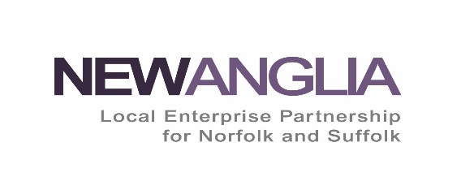
Apprenticeship Levy Transfer Form
In order to receive apprenticeship levy transfer, please complete this form and return to:
Alison Ward New Anglia Apprenticeship Coordinator
Email: alison.ward@newanglia.co.uk

Receiving Employer Information
Section 1
Company Name of Receiving Employer:
Name of Contact at Receiving Employer:
Contact email:
Contact telephone number:
Company Address:
Company Post code:
Sector you work in:
Number of employees:
Do you pay into the Apprenticeship Digital Account? | Name of person managing your apprenticeship account; | Email:  Telephone:
Employer Apprenticeship Account ID

Section 2
I understand that transferred funds can only be used to pay for the training and assessment cost of apprenticeship standards. | Y / N
We have set up an account with the apprenticeship service, and have a signed agreement with the Education and Skills Funding Agency (ESFA) | Y / N
I understand that transfers are managed through the apprenticeship service, and payments are transferred each month from the sending employer account into the receiving employer account which is then accessed via approved training providers to fund Apprenticeship delivery | Y / N
Have you previously received an Apprenticeship Transfer of funding? | Y / N
Are you currently transferring levy funds to another employer? | Y /N

Section 3
Do you have a preferred training provider?  - If answered Yes to the above, please name your preferred training provider and contact details if known | Y / N
Is this funding for an existing employee who requires significant new skills? | Y / N |  | Name of apprentice
Apprentices start and end date | Start Date |  |  |  |  | Predicted End Date
Apprenticeship Standard | Level | Title |  |  |  |  | Duration |  | Cost

Section 4
So that the transferring employer can understand the need for the funds, please provide a short explanation (no more than 200 words) of why your organisation is requesting levy transfer funding and the benefits this will bring to your organisation.

Declaration:
In receiving a transfer, you agree to comply with the ESFA Funding Rules for Apprenticeship Levy Transfers. Please ensure you read the information for receiving employers.
Information for employers can be found using the following link:
https://www.gov.uk/guidance/apprenticeship-funding-rules-for-employers/apprenticeships-funded-by-transfer-of-levy-funds
Are you a member of governments Disability Confident scheme? https://disabilityconfident.campaign.gov.uk/ | Yes / No
Have you signed up to the Armed Forces Covenant?  https://www.gov.uk/government/publications/corporate-covenant-guidance | Yes / No

Name:
Date:
I agree to comply with the ESFA Funding Rules | Y es / No

Office use only: To be completed by New Anglia LEP
Name of Transferring organisation:
Contact Name:
Contact email:
Transferring organisation agreed to transfer | Date:

