LEARNING AND SKILLS SECTOR
SKILLS PLAN
Skills Board endorsed version

Putting skills at the heart of building
a competitive and sustainable
local economy

March 2019

Background Context
The Learning and Skills Sector Skills Plan has been developed with the sector in Norfolk and Suffolk, working alongside the New Anglia Local Enterprise Partnership, the New Anglia Skills Board and supported by SkillsReach.
SkillsReach was contracted to facilitate and prepare eight sector skills plans for the New Anglia LEP priority sectors. The project was commissioned by the Education and Skills Funding Agency, in partnership with New Anglia LEP, and funded through the European Social Fund. Each Sector Skills plan and supporting Data Pack has been developed in collaboration with local employers and other stakeholders.
The New Anglia Skills Board places employers at the centre of decision making on skills in Norfolk and Suffolk to ensure the skills system becomes more responsive to the needs of employers, residents and the future economy.
SkillsReach is an established East of England-based strategic skills consultancy with an associate project team with extensive experience of developing skills plans.

Executive Introduction

‘Welcome to the Learning and Skills Sector Plan for New Anglia. It sets out our collective vision for how local skills provision can increase local competitiveness and productivity, support inclusive economic growth and ensure that high quality local career-pathways are recognised, accessible and taken up by local people.
This plan is a key step in the development of a regional collaboration between business, localities and skills providers to ensure inclusive growth, and that skills opportunities are connected and maximised for businesses and local residents.

We look forward to making an increasing and sustainable contribution to the future of our vibrant New Anglia Economy’.
Signed……
Corienne Peasgood
Principal, City College, Norwich

Contents
Executive Introduction 3
1 Learning and Skills Sector Skills Plan- the Key Priorities 5
Challenges and Opportunities 6
Proposed Skills Interventions 11
Partnership Strategy 25
2 The Learning and Skills Sector in Context 26
Defining the Learning and Skills Sector 28
Routes into Learning and Skills Careers 29
3 Stakeholder Feedback 31
Developing Technical Specialism 31
Developing a Cross-cutting Approach 32
Leveraging Employer Investment in Skills 34
Future Proofing Technical Expertise 34
Vacancy Filling and Workforce Development 36
Apprenticeships 36
HE- Talent Retention 37
Employment Demand & Future Forecasting 37
Key Workforce Challenges- Summarised 38
Leadership and Management in the Learning and Skills Sector 39
Supporting Careers Leadership and Delivery 41
Appendix A- Skills Plan Development Process 46
List of Consultees 48

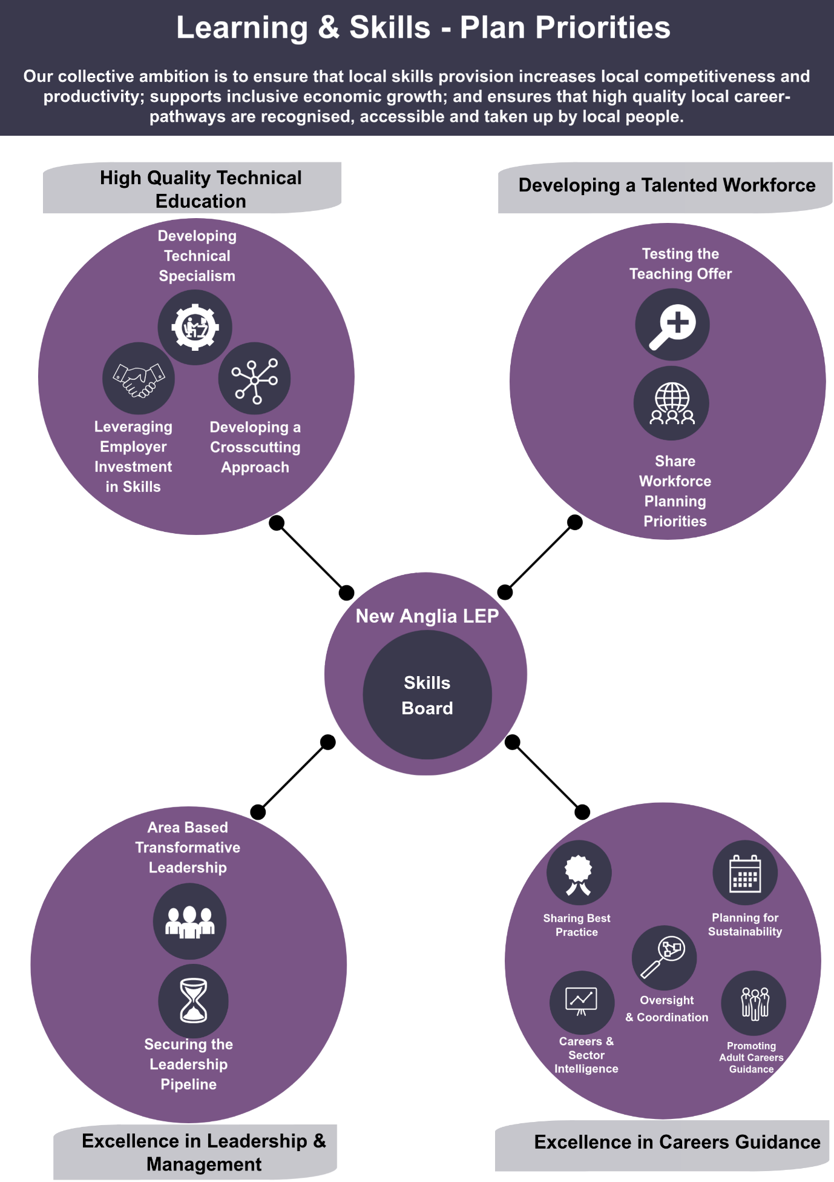
1 Learning and Skills Sector Skills Plan- the Key Priorities

Challenges and Opportunities
The data analysis and qualitative consultation (detailed in the subsequent chapters in this report) have enabled an evidence base to be developed that captures and defines a range of issues and risks linked to the demand and supply of skills for the Learning and Skills sector in New Anglia. In contrast, there are a range of strengths and major opportunities to position the skills plan against, giving planned interventions real momentum moving ahead.
The consultation has highlighted four key priorities of action for the skills plan to address:
- High Quality Technical Education
Government policy for post-16 vocational education has positioned technical reform as an overarching priority, with skills seen as a major contributor for developing world leading competitiveness in the UK’s economy. Alongside this is a growing expectation from employers to benefit from high quality vocational training, underpinned with high quality, fit for purpose, technical standards. Both the Industrial Strategy and the Post-16 skills reform position ‘localism’ as providing the catalyst for these changes.
There remain however fundamental challenges. Recruitment into the Learning and Skills sector can be difficult for specific teaching roles, particularly for high demand subjects and areas of training and education that require niche/specialised skills. The sector has highlighted the challenges of maintaining technical expertise in response to vocational skills reform: encouraging ex-industry specialism into high priority areas such as engineering, advanced manufacturing and digital skills, with wage rates cited as a major barrier.
Furthermore, leadership and investment from industry is imperative for the supply of current and future skills to be resilient and valuable in terms of building competitiveness in New Anglia’s economy. The Learning and Skills sector recognises there needs to be enhanced collaboration and planning as a ‘sector community’ and extra emphasis on aligning skills with employer leadership, business investment and growth within local economic strategy.
The first key aim of the New Anglia Learning and Skills Sector Skills Plan is to work collaboratively, as a learning and skills community and together with partners including the New Anglia LEP, to develop the effective level of leadership and investment needed from employers, for high quality technical education to be secured and sustained.
The first key outcome of the New Anglia Learning and Skills Sector Skills Plan is that local employers benefit from world class, technically excellent training; enabling the acquisition, utilisation and ongoing development of skills.

- Developing a Talented Workforce
The Learning and Skills sector in New Anglia experiences relatively high levels of unfilled and hard to fill vacancies, compared to both regional and national averages. The sector also experiences organisational concerns regarding the utilisation and level of proficiency of staff – again higher than local and national averages for all sectors. The concerns relating to underutilisation and proficiency are partly driven by teaching professionals having to respond to dual/multi-professionalism subject delivery and a balance of responsibilities aligned with teaching and individual learner support (SEND for example). Whilst the focus within this plan is set out against a scope of post-16 education and training, with an emphasis on technical skills there are wide variations of training needs within learning and skills teaching and delivery. For example, a lecturer in engineering with strong links to industry compared to a tutor in foundation learning or A-Level academic delivery. This impacts on diversity of needs linked to labour market information, building workforce resilience and responding to external demands.
There are however structural, labour market, challenges linked to the flow of talent and availability of suitably qualified teaching professionals in line with current and forecast demands. The Learning and Skills sector recognises the need to test the teaching offer for the key sectors defined as being most important for New Anglia’s growth and competitiveness. In addition, the sector is keen to share and collaborate on action linked to workforce planning, the development of niche expertise and marketing careers within learning and skills in New Anglia.
The second key aim of the New Anglia Learning and Skills Sector Skills Plan is to develop collaborative workforce development planning processes for the Learning and Skills sector across New Anglia. Joint planning will enable providers to define common workforce priorities in response to external education and training demands and labour market challenges. Furthermore, it will provide ongoing options for managing risks, building organisation resilience and sharing expertise.
The second key outcome of the New Anglia Learning and Skills Sector Skills Plan is a resourceful and resilient New Anglia learning and skills sector that continues to work proactively to ensure it is adaptable to change; ensuring education and training delivery is of a high standard and responsive, with a well organised and highly professional workforce.
- Excellence in Leadership and Management
The Learning and Skills sector recognises that the development of management skills and securing the leadership pipeline for senior roles is a major challenge overall and one that builds internal resilience and effective external ‘whole system’ collaboration on learning and skills. There are examples in New Anglia of how leadership development is being coordinated across several group-based approaches: from early years through to FE and HE, with several key sectors also including strong industry linked partnerships. There are also a range of interactions and sponsorships aligned to the Education and Training Foundation’s ongoing leadership development programmes.
The Learning and Skills sector is keen to develop further area-based leadership collaboration. This would be aimed at addressing system wide leadership challenges and informal peer-support arrangements looking at transformative initiatives aimed at developing leadership by working across the civic, voluntary and private sectors.
The third key aim of the New Anglia Learning and Skills Sector Skills Plan is to design and share across all years’ education in New Anglia, a collaborative plan for management and leadership development. The plan will organise activity aimed at promoting how education leadership can be developed via local, external, transformative challenges and internal best practice in management development.
The third key outcome of the New Anglia Learning and Skills Sector Skills Plan is that the learning and skills sector in New Anglia benefits from talented managers and leaders, with its workforce effectively supported and education delivery to a high standard, and with communities benefitting from supportive local leadership.
- Excellence in Careers Guidance
Since the implementation of the new National Careers Strategy in 2017 and the establishment of the national Careers and Enterprise Company (CEC), schools and colleges are encouraged to take a more proactive and strategic approach towards careers and enterprise delivery in order to equip the next generation of school and college leavers with the appropriate employability and enterprise development that employers will value. OFSTED will expect to see evidence on how independent careers guidance is provided in schools to all year 8-13 pupils (12-18-year olds) and that it must be provided in an impartial manner.
Both Norfolk and Suffolk County Councils take a strategic approach toward the planning and provision of careers guidance, emphasising important issues linked to the quality of delivery across all ages and assessing the capacity to deliver interventions for a diverse range of needs, including via SEND provision and support for NEETs. In addition, New Anglia LEP leads a network of Enterprise Advisers (EAN), that works in partnership with Norfolk and Suffolk County Councils and the National Careers Service (operated by Futures) to develop a joined-up response to the National Careers Strategy. The EAN has a focus on supporting Gatsby Recommendations as a measure but also takes a broad focus on key issues aligned to the Careers Strategy. These include access to and delivery of Careers Leader training (funded via DfE and controlled via the CEC, with Suffolk County Council one of the formally approved providers) and the overall sharing of best practice across the school and college network. Furthermore, the strategic focus taken by Norfolk and Suffolk County Councils covers the planning of action that includes effective provision of advice and guidance, with effective interventions, for young people with Special Education Needs (SEND) and those that are either at risk of or are seen to be Not in Education, Employment or Training (NEET). New Anglia was one of the successful LEP areas to win a share of the extra £5 million investment the government has ringfenced to further promote the adoption of careers and enterprise activity linked to the national strategy- via Careers Hubs.
Several key issues linked to developing excellence in careers guidance have been identified via the consultation: ensuring existing resources are used effectively, recognising the importance of area-wide collaboration and planning and ensuring that careers guidance is developed strategically through a comprehensive approach. Four key thematic opportunities have been identified:
Establishing effective oversight and coordination - of careers and enterprise planning and intervention across New Anglia.
Testing and Effective Use of Labour Market Intelligence - both careers and enterprise leads within Norfolk and Suffolk County Councils have advocated for ongoing measures to test the relevancy, accuracy and quality of labour market intelligence with employers and schools.
Promoting Best Practice – encourage the promotion of best practice in delivery that can showcase initiatives that both inform the Careers Hub and can be disseminated to schools and colleges across the whole of New Anglia.
Planning Sustainability - there are three key challenges in terms of addressing sustainability for effective careers and enterprise guidance are:
- Funding and resources beyond 2020 that provide ongoing CPD for the careers guidance community and can build on ‘operational’ initiatives such as the Careers Hub.
- Promoting collaboration and ongoing alignment of partnership and organisation activity against a strategic overarching focus for New Anglia, which can create a shared vision and set of outcomes; and can maximise efficiency through effective collaboration.
- Developing a framework of quality assurance that can consider how to effectively baseline the capability of delivering effective careers guidance across all years’ education and training, including provision of excellent careers guidance specific to the needs of SEND, NEETs and other vulnerable groups.

Taking a Strategic Approach Towards Careers Advice and Guidance for Adults– stakeholders have raised concerns regarding the paucity of strategic focus via the National Careers Strategy regarding advice and guidance available for adults. This effects people in work looking to progress, move jobs and plan career changes and adults looking to enter employment.
The fourth key aim of the New Anglia Learning and Skills Sector Skills Plan is to develop a strategic approach toward the coordination, delivery and forward sustainability planning of careers guidance and enterprise across New Anglia. Ensuring aims are in line with the National Careers Strategy, measuring quality, promoting diversity in provision to all young people and adults, including vulnerable groups - with strong involvement and assurance from the business community.
The fourth key outcome of the New Anglia Learning and Skills Sector Skills Plan is that young people and adults benefit from effective career’s guidance and enterprise initiatives, ensuring they make informed choices regarding ongoing learning and careers options, develop valuable employability skills and make positive progressions into work and economic independence.

Proposed Skills Interventions
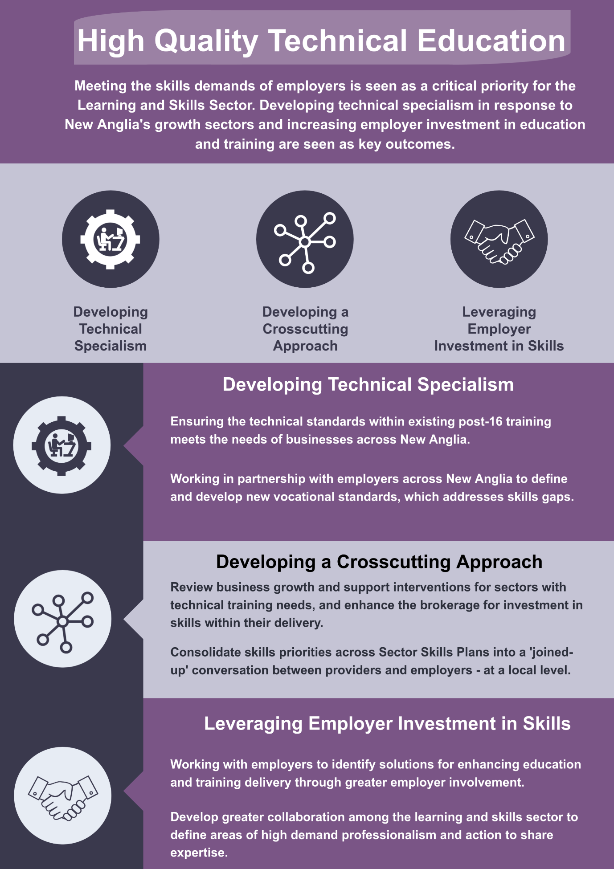
Priority 1- High Quality Technical Education

Recruitment into the learning and skills sector can be challenging, particularly for high demand subjects and areas of training and education that require niche/specialised skills. The sector has highlighted the challenges of maintaining technical expertise in response to vocational skills reform: encouraging ex-industry specialism into high priority areas such as engineering, advanced manufacturing and digital skills, with wage rates cited as a major barrier.

Furthermore, leadership and investment from industry is imperative for the supply of current and future skills to be resilient and valuable in terms of building competitiveness in New Anglia’s economy. The Learning and Skills sector recognises there needs to be enhanced collaboration and planning as a ‘sector community’ and extra emphasis on aligning skills with employer leadership, business investment and growth within local economic strategy.

Key Aims and Outcomes:

To work collaboratively, as a learning and skills community and together with partners including the New Anglia LEP, to develop the effective level of leadership and investment needed from employers, for high quality technical education to be secured and sustained.

The outcome of which - local employers benefit from world class, technically excellent training; enabling the acquisition, utilisation and ongoing development of skills.

Action to be Taken:

Three long term areas of action should be developed under the auspices of the Skills Board, these are:

- Developing technical specialism by ensuring the technical standards within existing post-16 training meets the needs of business across New Anglia. This would involve a gap analysis assessing how New Anglia’s specific skills priorities that are reliant on technical specialism, are currently supported with up to date technical standards, accessible through local skills provision. Gaps in standards or out of date standards risk creating skills supply shortfalls. A process of assessing standards would need to include remedial action – planning for the definition of new standards via local employer-led sponsors and working with government to deliver accredited outcomes. (Developing specialism within teaching is captured in Priority 2)

- Developing a Crosscutting Approach – enhance the business growth and support interventions for employers with technical training needs, by reviewing how skills and training is effectively brokered. A key starting point would be assessing how the LEP’s Growth Hub and LEP commissioned business support provision can effectively broker employer investment in skills alongside other recommended action. The Skills Board should be consulted on how productivity and growth advice and guidance correlate to skills and training, helping business support to clearly articulate the business case for skills when advising local businesses. In addition, local training providers are keen to develop a regular ‘skills conversation’ with businesses at an area level. The Skills Board should consider how a cross-sector local skills event can help training providers develop their employer offer and raise the profile of skills solutions, with employers.

- Leveraging Employer Investment in Skills- The New Anglia LEP should encourage skills leaders to work with them to review how commitments around investment in skills- both in terms of training/upskilling and other resources (trainer support, input on quality assurance and donation of kit/equipment) can be most effectively promoted across the range of business support funding processes that are currently accessible. This may involve lobbying policymakers nationally to promote greater focus on skills as part of any grant funding frameworks. In addition, niche technical professionalism should be identified through R&D, investment and grant based support activities; and employers should be encouraged to work with the learning and skills sector to develop technical excellence in teaching and training.

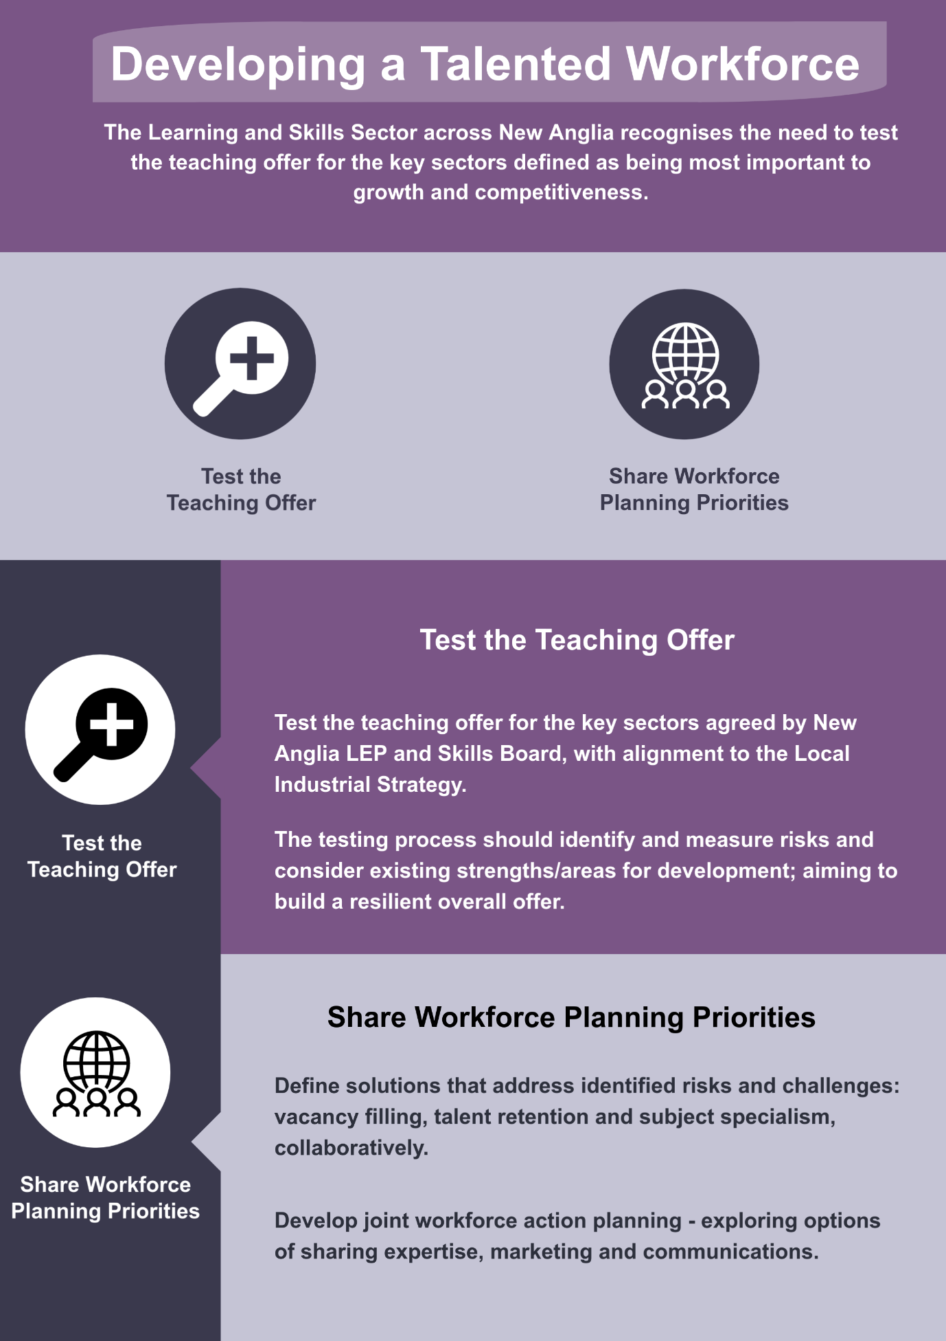

Priority 2- Developing a Talented Workforce

The Learning and Skills sector in New Anglia experiences relatively high levels of unfilled and hard to fill vacancies, compared to both regional and national averages. The sector also experiences organisational concerns regarding the utilisation and level of proficiency of staff – again higher than local and national averages for all sectors. The concerns relating to underutilisation and proficiency are partly driven by teaching professionals having to respond to dual/multi-professionalism subject delivery and a balance of responsibilities aligned with teaching and individual learner support (SEND for example).

There are structural, labour market, challenges linked to the flow of talent and availability of suitably qualified teaching professionals in line with current and forecast demands. The Learning and Skills sector recognises the need to test the teaching offer for the key sectors defined as being most important for New Anglia’s growth and competitiveness. Furthermore, the sector is keen to share and collaborate on action linked to workforce planning, the development of niche expertise and marketing careers within learning and skills in New Anglia.

Key Aims and Outcomes:

To develop collaborative workforce development planning processes for the Learning and Skills sector across New Anglia. Joint planning will enable providers to define common workforce priorities in response to external education and training demands and labour market challenges. Furthermore, it will provide ongoing options for managing risks, building organisation resilience and sharing expertise.

The outcome of which – a resourceful and resilient New Anglia learning and skills sector continues to work proactively to ensure it is adaptable to change and that education and training delivery is of a high standard and responsive, with a well organised and highly professional workforce.

Action to be Taken:

Medium Term (6-12 months)

- Test the current teaching offer for the key sectors, considering ongoing priorities for alignment with emerging strategies (for example the Local Industrial Strategy) and national policy on skill reform. The testing process should identify and measure risks by cross-referring to the Skills Board’s suite of skills plan priorities. Existing strengths and areas for development should be considered alongside aiming to identify action, agree outcomes and build a resilient offer overall.

- Through the Skills Board agree how the FE and Independent Training Provider groups can develop joint workforce development planning, identifying solutions to shared challenges linked to vacancy filling, talent retention and academic supply shortfalls in key subject areas. Providers should consider how regular collaborative workforce planning can forecast teaching demands, explore options on cooperative sharing of teaching expertise; and profile the age and competency levels of the existing workforce.

- Using feedback from workforce planning activity, identify where marketing and communications can help address external pressures linked to recruitment and retention. This should include the promotion of education careers and the development of excellence in learning skills as a New Anglia brand – aiming to grow the sector’s competitiveness.

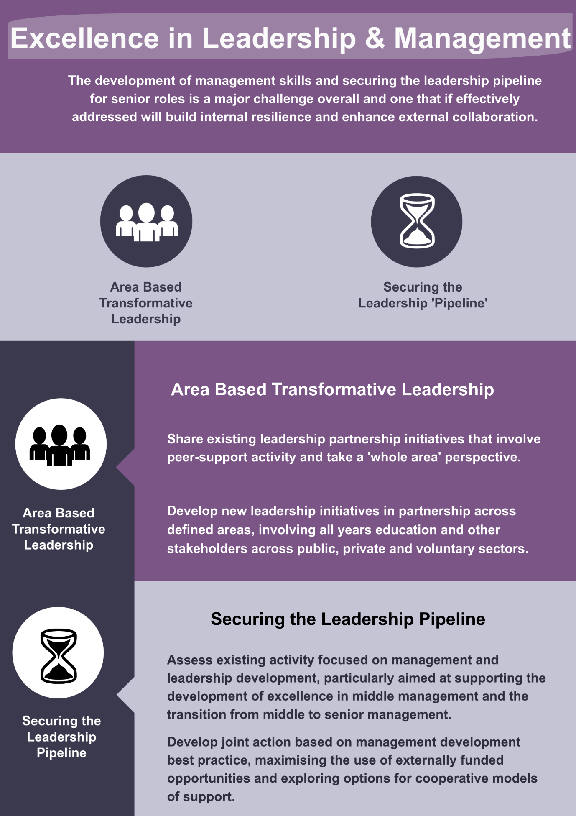

Priority 3 – Excellence in Leadership & Management

The Learning and Skill sector recognises that the development of management skills and securing the leadership pipeline for senior roles is a major challenge overall and one that builds internal resilience and effective external ‘whole system’ collaboration on learning and skills. There are examples in New Anglia of how leadership development is being coordinated across several group-based approaches: from early years through to FE and HE, with several key sectors also including strong industry linked partnerships. There is also a range of interaction and sponsoring aligned to the Education and Training Foundation’s ongoing leadership development programmes.

The Learning and Skills sector is keen to develop further area-based leadership collaboration. This would be aimed at addressing system wide leadership challenges and informal peer-support arrangements looking at transformative initiatives (for example addressing social and economic deprivation) aimed at developing leadership by working across the civic, voluntary and private sectors.

Key Aims and Outcomes:

To design and share across all years’ education in New Anglia, a collaborative plan for management and leadership development. The plan will organise activity aimed at promoting how education leadership can be developed via local, external, transformative challenges and internal best practice in management development.

The outcome of which – the learning and skills sector in New Anglia benefits from talented managers and leaders, with its workforce effectively supported and education delivery to a high standard, and with communities benefitting from supportive local leadership.

Action to be Taken:

Short Term (3-6 months)

- Through the role of the Skills Board, share existing learning and skills leadership partnership initiatives that involve peer-support activity and takes a ‘whole area’ perspective.

- Assess how the Skills Board can continue to engage with area based transformative leadership, developing a plan to support ongoing leadership development for the sector in this way.

Medium Term (6-12 months)

- Consult with partners on how new leadership initiatives, involving all year’s education and with other stakeholders across public, private and voluntary sectors, can be developed. Planning should establish the aims and outcomes of how external leadership can engage with local challenges and offer a focused role for education.

Long Term (12 months+)

- Assess existing activity focused on management and leadership development across FE, the Independent Training provider partnership and HE represented at the Skills Board. Share lessons learnt and perform a joint appraisal (SWOT etc) via a Skills Board Task and Finish Group, to capture challenges and opportunities, and to promote the development of joint action.

- The FE College Group also highlighted the importance of developing excellence in middle-management alongside activity focused on securing the pipeline of senior leaders and effective governance. Advocate for the College Group to develop a shared plan for developing middle management - targeting resources, leveraging external funding and exploring options for greater cooperation.

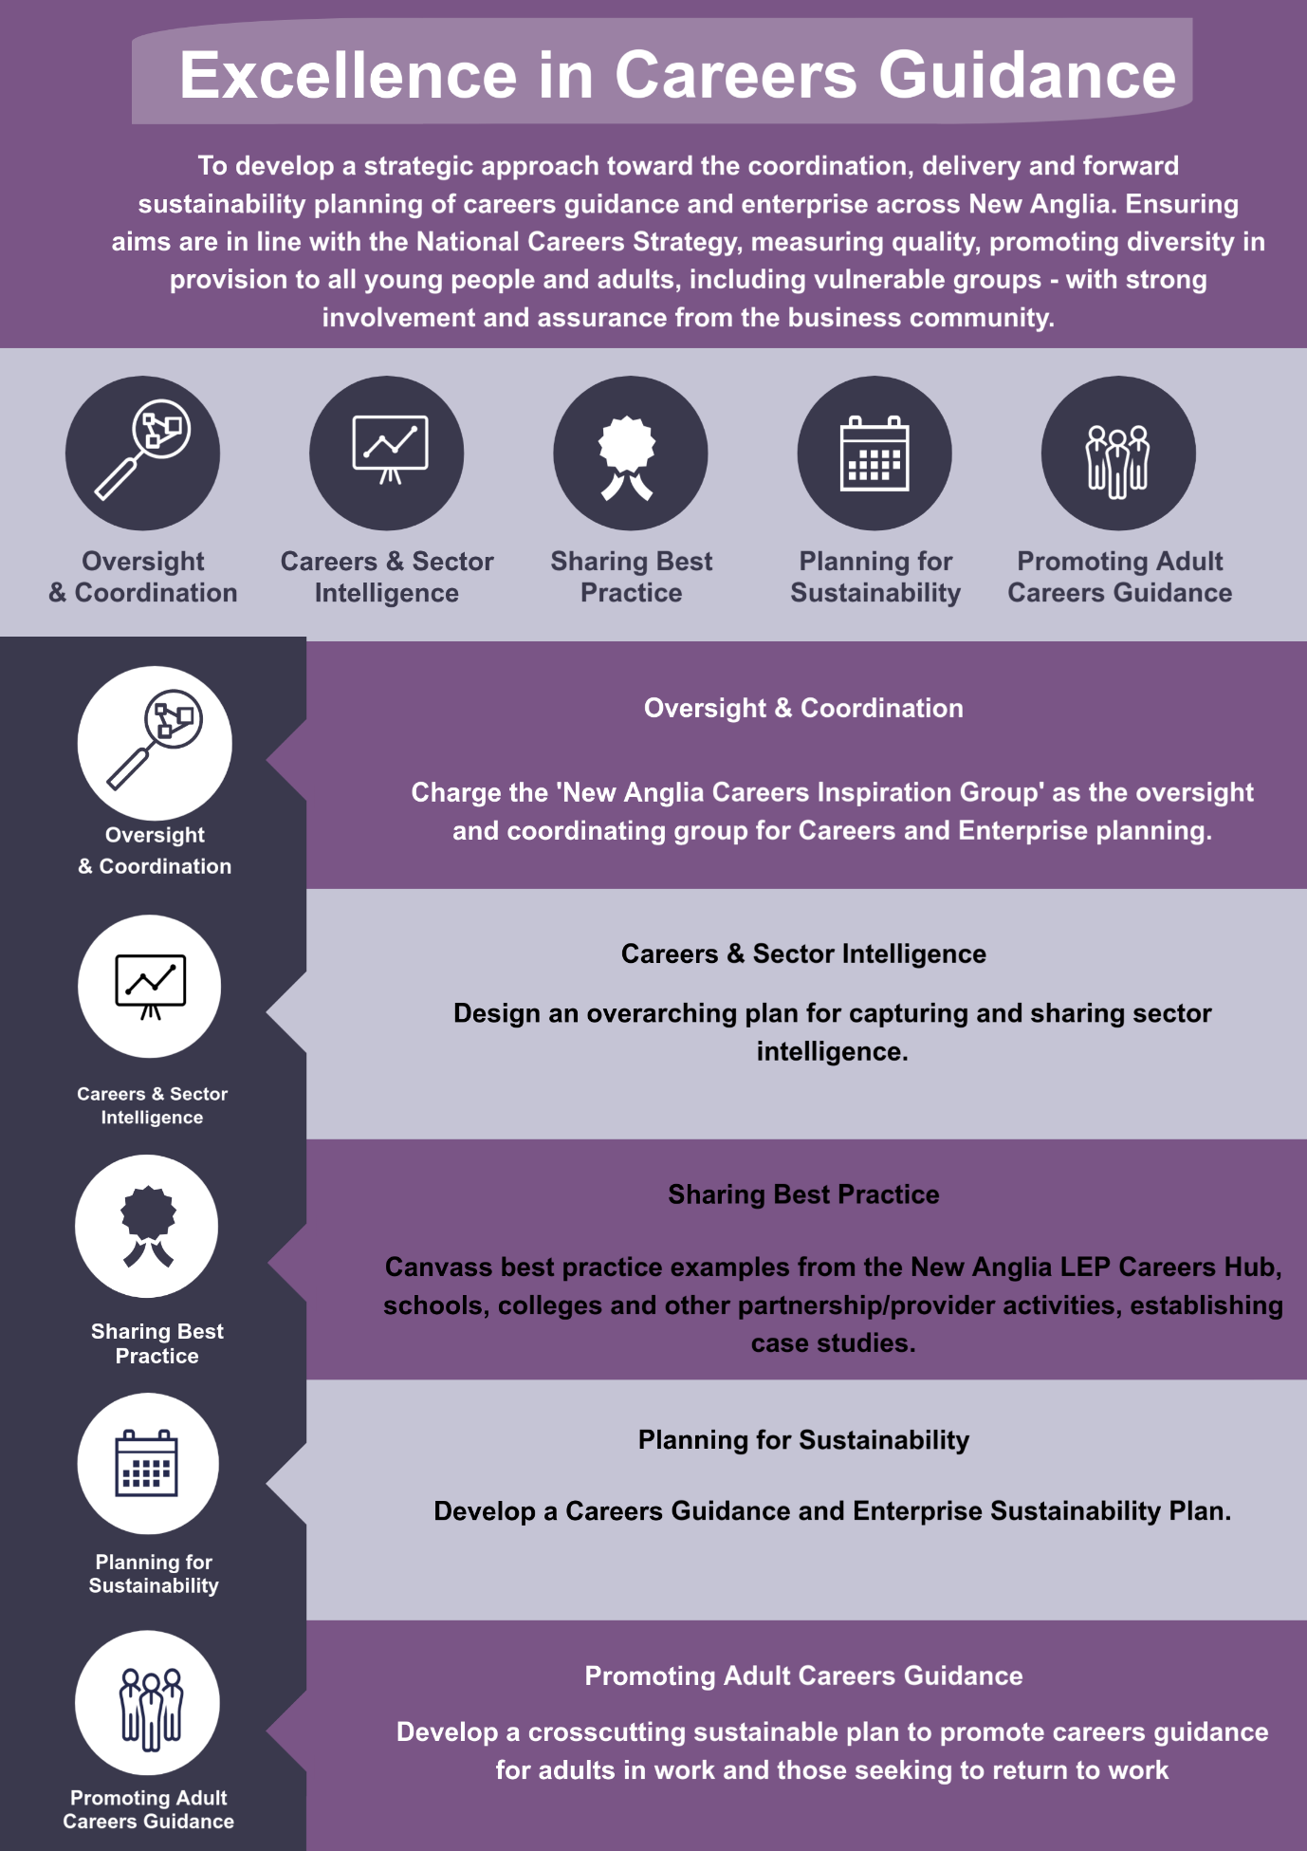

Priority 4 – Excellence in Careers Guidance

Since the implementation of the new National Careers Strategy in 2017 and the establishment of the national Careers and Enterprise Company (CEC), schools and colleges are encouraged to take a more proactive and strategic approach towards careers and enterprise delivery in order to equip the next generation of school and college leavers with the appropriate employability and enterprise development that employers will value. OFSTED will expect to see evidence on how independent careers guidance is provided in schools to all year 8-13 pupils (12-18-year olds) and that it must be provided in an impartial manner.

Both Norfolk and Suffolk County Councils take a strategic approach toward the planning and provision of careers guidance, emphasising important issues linked to the quality of delivery across all ages and assessing the capacity to deliver interventions for a diverse range of needs, including via SEND provision and support for NEETs. In addition, New Anglia LEP co-ordinates an Enterprise Adviser Network (EAN) that works in partnership with Norfolk and Suffolk County Councils, to develop a joined-up response to the National Careers Strategy. The EAN has a focus on supporting Gatsby Recommendations as a measure but also takes a broad focus on key issues aligned to the Careers Strategy. These include access to and delivery of Careers Leader training (funded via DfE and controlled via the CEC, with Suffolk County Council one of the formally approved providers) and the overall sharing of best practice across the school and college network. Furthermore, the strategic focus taken by Norfolk and Suffolk County Councils covers the planning of action that includes effective provision of advice and guidance, with effective interventions, for young people with Special Education Needs (SEND) and those that are either at risk of or are seen to be Not in Education, Employment or Training (NEET).

New Anglia was one of the successful LEP areas to win a share of the extra £5 million investment the government has ringfenced to further promote the adoption of careers and enterprise activity linked to the national strategy- via Careers Hubs. At this stage a process of alignment is in development between the Enterprise Adviser Network, Norfolk and Suffolk County Councils and the New Anglia LEP – to carry forward the planned action of the Careers Hub and ensure the strategic focus developed via the EAN is maintained. The New Anglia LEP Careers Hub is made up of 32 local schools and colleges in Ipswich, Norwich and along the A140 corridor, working together with universities, training providers, employers and career professionals to improve careers education. The Hub will also work closely with the schools and boards of the Ipswich and Norwich Opportunity Areas.

Several key issues linked to developing excellence in careers guidance have been identified via the consultation and should be considered in the context of a primarily rural, sparsely populated area:

Promoting Best Practice – encourage the promotion of best practice from across New Anglia in delivery that can showcase initiatives that both inform the Careers Hub, provide CPD for practitioners and can be disseminated to schools and colleges, independent training providers and organisations delivering support within the voluntary and community sector, across the whole of New Anglia.

Planning Sustainability - stakeholders have raised the issue of sustainability planning as a key strategic challenge for careers guidance delivery across New Anglia. Funding and resources for the Careers Leader Training Programme are essentially finite, with funds either stopping or reducing from 2020. Furthermore, there is a diverse and complex landscape of delivery and activity in play both in within the Careers Hub direct and at a wider level: across education business partnerships and private providers (Beacon East, ConnectEB, All Together, the two Chambers of Commerce for New Anglia and private providers of careers guidance support – to name but a few). Careers guidance is also often a key feature of support programmes delivered via the voluntary and community sector, which aims to address economic and social inclusion. Furthermore, there are other key established resources, for example the “icanbea…” website and the range of action drawn together by overarching programmes such as Suffolk’s “Raising the Bar” strategy that aims to improve the levels of education attainment via multisector partnership working. Further activity includes the National Collaborative Outreach Programme (NCOP), which aims to widen participation within Higher Education through supporting HEI outreach and engagement with schools and colleges. Locally the national NCOP activity is delivered as the Network East Anglia Collaborative Outreach programme (NEACO), led by the University of Cambridge and aiming to widen HE participation across Norfolk and Suffolk.

In summary, the three key challenges in terms of addressing sustainability for effective careers and enterprise guidance are:
- Funding and resources beyond 2020 that provide ongoing CPD for the careers guidance community and can build on ‘operational’ initiatives such as the Careers Hub.
- Promoting collaboration and ongoing alignment of partnership and organisation activity against a strategic overarching focus for New Anglia, which can create a shared vision and set of outcomes; and can maximise efficiency through effective collaboration.
- Developing a framework of quality assurance that can consider how to effectively baseline the capability of delivering effective careers guidance across all years’ education and training, including provision of excellent careers guidance specific to the needs of SEND, NEETs and other vulnerable groups.

Taking a Strategic Approach Towards Careers Advice and Guidance for Adults– stakeholders have raised concerns regarding the paucity of strategic focus via the National Careers Strategy regarding advice and guidance available for adults and the lack of synergy between adult and young people careers support. This affects people in work looking to progress, move jobs and plan career changes and adults looking to enter employment. The current localised approach is extensively focused on young people and students, however there is a crosscutting principle evident in the collection of Skills Plans for New Anglia which highlights the need for flexibility within the local workforce and for greater measures to retain graduates locally.

Testing and Effective Use of Labour Market Intelligence - both careers and enterprise leads within Norfolk and Suffolk County Councils have advocated for ongoing measures to test the relevancy, accuracy and quality of labour market intelligence with employers and schools. Feedback highlighted that organisations engaging with careers guidance should be empowered to develop their own processes for accessing and using labour market intelligence but that there should be supportive scrutiny to ensure that data is fit for purpose. The recent Area Review corroborated this issue, with a commitment for Norfolk and Suffolk County Councils and New Anglia LEP to work collaboratively to develop good quality information on local employment, sectors, skills needs and key developments that may provide opportunities for career progression.

Key Aims and Outcomes:

To develop a strategic approach toward the coordination, delivery and forward sustainability planning of careers guidance and enterprise across New Anglia. Ensuring aims are in line with the National Careers Strategy, measuring quality, promoting diversity in provision to all young people and adults, including vulnerable groups - with strong involvement and assurance from the business community.

The outcome of which – young people and adults benefit from effective career guidance and enterprise initiatives, ensuring they make informed choices regarding ongoing learning and careers options, develop valuable employability skills and make positive progressions into work and economic independence.

Action to be Taken:

Short Term (3-6 months)

- Charge the ‘New Anglia Careers Inspiration Group’ as the oversight and coordinating group for Careers and Enterprise skills planning.

- Design an overarching plan for capturing and sharing sector intelligence. The plan should be developed in line with the national Careers Strategy and the Gatsby expectations. The plan should aim to:

  - enable the diverse network of stakeholders, including the New Anglia Careers Hub, local authorities, independent careers / training providers, schools, colleges, HE and the voluntary and community sector - to access relevant labour market insight from sector skills partnerships established via the range of skills plans - on an ongoing basis.
  - specify how sector skills plan priorities involving employer sponsorship and involvement, can be effectively coordinated.
  - Work with and promote existing LMI resources, such as national tools (e.g. Labour Insight / Burning Glass) and local initiatives such as “icanbea...”
  - Test the relevancy, accuracy and quality of labour market intelligence available on an ongoing basis via employer assurances.

Medium Term (6-12 months)

- Canvass best practice examples from schools, colleges and other partnership/provider activities, establishing case studies that can be set out against the Gatsby framework recommendations – across all New Anglia. Ensure that the case studies are broadly disseminated via the EAN and Careers Hub and via online media (LEP website etc). Best practice should also promote examples of digital service development, excellence with SEND support, NEET provision, disadvantaged groups and vulnerable young people and adults.

- Develop a Careers Guidance and Enterprise Sustainability Plan – focusing on three key elements:

  - An impact assessment of the reduction of funds and resources that support current CPD and delivery activity from 2020 onwards, with funding options.
  - The promotion of collaboration and ongoing alignment of existing networks and partnership activity, against a shared New Anglia vision and common set of outcomes – aiming to create an effective and efficient overarching strategy.
  - Developing a baseline for quality assurance in respect of the current capability/qualification of careers advice and guidance delivery across schools, colleges and independent providers for the benefit of all year’s education and training. This can help target support and CPD resources according to need, including careers guidance focused on primary, SEND, NEET provision, disadvantaged groups and vulnerable young people and the widest local adult audiences.

- Develop a crosscutting sustainable plan to promote careers guidance for adults in work and those seeking to return to work, by engaging with existing stakeholders such as ‘Futures for You’, sector-based groups and industry institutes that provide CPD, ensuring that local labour market information is both current and engaging. Agreed action should aim to make careers guidance provision accessible, of a high quality and relevant to the needs of local people and businesses.

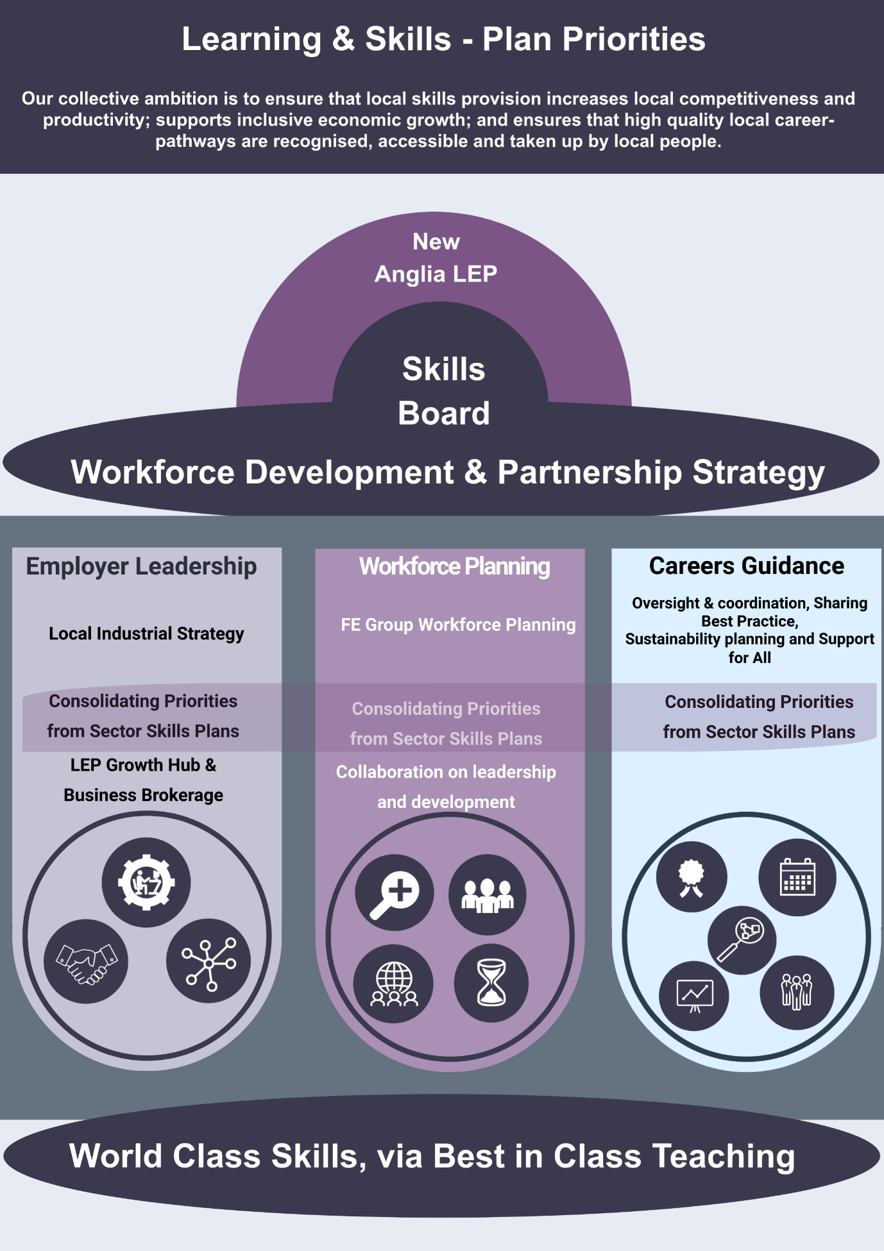
Partnership Strategy

2 The Learning and Skills Sector in Context

The New Anglia Local Enterprise Partnership (LEP) has sponsored the development of a Learning and Skills Sector Skills Plan for the New Anglia area.
There were just over 498,000 teachers working in state funded schools in England in 2017, which equates to 451,900 Full Time Equivalent (FTE), represented a 1.2% fall in total numbers between 2016 and 2017. Of this, there were 221,100 FTE working in nursery and primary and 204,200 FTE teachers working in secondary education.
For the Further Education (FE) workforce, defined in the broadest sense of the delivery of study in England taken after the age of 16 that is not part of Higher Education (HE), it was estimated there were 326,000 staff working across the sector in 2016. This equated to 250,000 staff working in colleges, 51,000 working in within the private sector work based training market and approximately 25,000 staff working within publicly funded Adult and Community Learning.
Nationally - the total spending on adult skills has fallen by 45% in real terms between 2009/10 and 2017/18, with the composition of funding shifting considerably toward work-based learning. The composition of apprenticeships and other work-based learning delivery stood at 7% of the adult skills funding budget nationally in 2002/03 and by 2017/18 it had increased to approximately 33%.
For Higher Education (HE), the total number of staff was estimated at 46,000 in 2016/17, an increase of 12.6% over a 10-year period, with 68% of this growth attributed to academic staff. Overall it is estimated 49% of all staff working in HE are on academic contracts. The Data Pack analysis uses workforce estimates by industrial classification; therefore, HE staff delivering HE provision within FE establishments will fall within the FE workforce statistic.
For New Anglia the size of the Learning and Skills sector workforce is estimated at 66,000, which represents a combination of education as a broad industrial group and the specific teaching occupational categories. The primary education workforce represents the largest banding of total employment overall for the sector across New Anglia, equating to 45% (28,000 staff).
At a regional level (East of England) there has been an overall increase in employment for the sector of 10% over the last 10 years; however, the absolute numbers employed within Further and Higher Education have contracted by approximately 10% over the same timeframe. In line with national trends the largest increase in employment has occurred within primary education.
Overall the Learning and Skills sector is worth £2.14 billion GVA to the New Anglia economy (LEP Economic Strategy Analysis), with enabling factors including the scale of employment, the spending and procurement investment impact locally and the subsequent multiplier effect that education bears within the local economy, affecting local businesses and suppliers. In addition, the outcomes relating to education and skills contributes toward an overall ‘knowledge economy’ underpinning all sectors’ growth, competitiveness and productivity.
As of 2017/18 there were 52 funded schools with sixth forms in New Anglia, including 8 local authority-maintained schools, 41 academies, 2 free schools and 1 university technical college. In addition, there were 10 special schools with sixth forms. From 2018 there were 6 FE colleges:
- City College Norwich
- Easton and Otley College
- East Coast College
- Suffolk New College
- The College of West Anglia
- West Suffolk College.
The University of East Anglia, University of Suffolk and the Norwich University of the Creative Arts, offer most of the Higher Education provision in New Anglia; however, all 6 of the FE colleges also deliver Higher Education provision. In 2015 to 2016, 7,670 apprenticeship places were delivered in Norfolk and 6,340 in Suffolk. The FE colleges in the area offered 6,550 apprenticeship framework enrolments between them. Overall, the most popular frameworks were business administration, children’s care learning and development, customer service, construction skills, health and social care, hospitality and catering, and management. There are many Independent Training Providers delivering apprenticeship frameworks to Norfolk and Suffolk residents, including large national training providers, most of whom are not based in the area and some of whom deliver very small numbers.
The FE colleges, together with sixth form colleges- Suffolk One, East Norfolk Sixth Form and Lowestoft Sixth Form, have formed a collaborative college group; working together with the New Anglia LEP to advance the delivery of education and skills in line with New Anglia’s economic strategy. There is also a network of New Anglia Learning Providers, a network of Independent Training Providers and Local Authority training delivery, also developing a joined-up approach with the New Anglia LEP. Both groups are represented on the New Anglia Skills Board and have a played a major role in contributing to the development of the suite of Skills Plans sponsored by the Skills Board that are aligned to New Anglia LEP’s priority sectors.

Defining the Learning and Skills Sector

In developing this Skills Plan, we have considered both the broad industrial group of ‘Education’ (which captures both teaching and non-teaching activity), and the teaching occupations that fall under the broad occupational group of ‘Teaching and Educational Professionals’. A full breakdown of the industrial subsectors used (SIC codes) and the teaching and educational codes (SOC codes) is captured in the Learning and Skills Sector DataPack, which captures the detailed quantitative analysis of the scale, value and skills trends for the sector in New Anglia. (Available on request).
The consultation has involved a broad enquiry across the New Anglia education and skills sector; this has included research and stakeholder engagement on early years, primary, secondary and post 16 delivery. The focus of the consultation has however focused on two principle areas:
- activity within primary and secondary education that focuses on the development of careers and enterprise delivery in support of the transition young people make into post 16 learning and skills choices.
- Post 16 learning and skills delivery itself, with an emphasis on Further Education (FE) and the role of the independent training market, across New Anglia.
The data analysis has performed a broad assessment of learning and skills at all years, including Higher Education (HE) however the qualitative focus for the development of the plan has concentrated more specifically on the 16-19 academic and vocational delivery of learning and skills overall. This is line with the core remit of the skills plans supporting Education and Skills Funding Agency (ESFA) priorities.
The scope of consultation has also been iterative, adapting to the feedback provided by stakeholders as the planning work developed. As leadership within education was cited as a key priority by consultees working both within pre and post 16 learning and skills, the consultation has explored themes of all years’ education as a ‘whole system’ across New Anglia. This has informed the key priorities concluded within the plan.

Routes into Learning and Skills Careers

There are a range of pathways into the Learning and Skills sector in England. At a broad level the routes can be grouped into two main areas- (i) teaching as a professional role within education and training, including tutors of vocational training and (ii) non-academic or non-core academic roles, including administration, management and leadership, business administration, advisory specialisms and research. Formal guidance for those interested in pursuing a career as a teacher, groups options based on traditional postgraduate and undergraduate routes:
- Postgraduate qualified teaching status (QTS)- this programme is offered by universities, colleges, SCITTs, and School Direct training providers in England. QTS can be achieved via the Assessment Only route- having a degree and substantial experience of working in a school, early years, or further education setting, this option enables QTS without undergoing a teacher training programme.
- Undergraduate Initial Teacher Training- an education degree that leads to QTS, including a specific route for early years education.
- Undergraduate degree plus QTS- a non-education degree, followed by further training that achieves QTS, which can be achieved via a post graduate certificate in education (PGCE) or a postgraduate diploma in education (PGDE) or via several other options including a post graduate teaching apprenticeship and direct employment, with further training, by an employer that leads to QTS.
- Level 5 Diploma in Education and Training- a 1 year, Level 5 Diploma in Education and Training (DET) programme, which is recognised as a teaching qualification for the post-16 sector. This can be achieved via a university or college-led pre-service training route, or via working as an unqualified Further Education teacher while training part-time.
There are also a range of vocational routes into practitioner, assistant and support professional roles within learning and skills. From 2020 onward the Education and Childcare T Level will introduce a new routeway from technical, higher and through to professional occupations for the sector. This includes occupations such as - Childcare Assistants, Teaching Support Assistants, Early Years Support Practitioners, Teaching Instructors and Teaching/Teaching Support Professionals.
Existing apprenticeship frameworks - covering Supporting Teaching and Learning in Schools at Level 2 and 3 and Learning and Development at Level 3 will effectively close to new starters from August 2020, as the new T Level occupational map is introduced. Alongside this are the already existing reformed apprenticeship standards for- Learning and Development Practitioner Level 3, Teaching Assistant Level 3 and Learning and Development Consultant at Level 5. These are 18-month courses with entry requirements typically set by the employer. Learning and development qualification at Level 3 can then support the progression toward professional registration with the Chartered Institute of Professional Development (CIPD).
Higher Education academic professionals are supported by a range of CPD qualifications linked to furthering their professional lecturing competencies. This includes CPD aimed at developing further expertise in a research field and teaching and learning development. Although there are a range of non-traditional routes available for entry, most lecturers have been awarded a good bachelor’s degree (2:i) and have achieved or are working toward a Masters/ PhD.

3 Stakeholder Feedback

Feedback from stakeholders from across the Learning and Skills sector in New Anglia, captured via the consultation, has highlighted that meeting the demands of employers remains a critical priority overall. Central to this are several key areas linked to the reform of vocational and technical skills, the role of ‘people’ defined in the new Industrial Strategy White Paper (one of the key ‘pillars’ seen as a driver for business productivity and growth), and the increasing shift toward localism for economic development policy and delivery.

Developing Technical Specialism
Firstly, to build technical skills teaching capacity; the national Industrial Strategy White Paper references the reform of technical skills, initially announced in the Post 16 Skills Plan, which in turn was a response to the Sainsbury (Independent Technical Panel Report) Review of Skills. Stakeholders, through the consultation, have reflected on the dual challenge of impacting the policy linked to the reform of technical skills and training within existing education delivery alongside new vocational qualifications being developed. Central to this challenge is priorities linked to employer investment: ensuring industry can provide input and sponsorship overall to help grow technical specialism. This employer sponsorship can be drawn across three main themes – (i) working in partnership with the learning and skills community to identify and define emerging skills needs, (ii) leveraging resources to support the investment in capital and training kit requirements and (iii) providing specialism toward training delivery itself.
The reform of vocational training is holistic in its approach toward all aspects of delivery. Apprenticeships have seen the transition from previous frameworks based on occupational areas to new standards that better represent the technical competency as defined by a business to perform in the job. The funding system has transitioned alongside this, with employers now having more ‘transactional power’ over training delivery. Alongside this has been the introduction of the apprenticeship levy, which places more emphasis on effective investment in workforce development for levy paying employers. T Levels, which are expected to cover around 25% of 16-18-year-old FE delivery by 2027, aim to offer a third choice alongside the academic and apprenticeship routeways on offer and build on the same employer co-design and definition of standards as with the reform of apprenticeships, moving away from traditional frameworks. The first three T Level routes (or maps) announced (from an initial 15 occupational areas) for delivery from 2020/21 onward cover:
- Digital Design,
- Education and Childcare
- Construction (design, survey and planning)
These routes incorporate a Level 3 (A Level equivalent) learning pathway aimed at 16-18-year olds over a 2-year period, which must include industry placement/s (and/or part-time relevant employment) as part of the balance between classroom and ‘on the job learning’. The T Level qualification is predominantly aimed at achieving a work outcome upon qualification; however, it can also lead to Higher level learning- across academic degree and higher apprenticeship options.
Alongside this are the already existing reformed apprenticeship standards for- Learning and Development Practitioner Level 3, Teaching Assistant Level 3, Teacher Level 6 and Learning and Development Consultant at Level 5.
The Learning and Skills sector across New Anglia regard the introduction of T levels and the ongoing reform of apprenticeships via new technical standards, as a major area of impact. The Industrial Strategy emphasises the convergence technical specialism will have with other key policy developments such at Institutes of Technology (IoTs) and the new National College networks. This therefore highlights that the implementation of technical reform is not limited to FE colleges or for training in niche/STEM based industry (although investment in STEM skills is a standout area of action for the Industrial Strategy overall) but will affect a range of colleges and HE, and their associated partnerships too.
The Learning and Skills community across New Anglia therefore anticipate that teaching to the reformed technical capability, in line with new national standards, is a key issue to plan for, as vocational training reform accelerates. Subject specialisms will be required which will impact on upskilling existing staff for teaching the new qualifications and for the recruitment of new tutors/teachers from industry, with current experience and an industrial ‘skillset’ that will match employer demand.

Developing a Cross-cutting Approach
Secondly, the Learning and Skills community recognises that a skills plan for their sector must help promote a ‘cross-cutting and underpinning’ series of actions. Consultation with the FE Principal and Vice Principal Groups emphasised that building inherent responsiveness within the ‘skills system’ should be positioned centrally within this skills plan. They see this responsiveness being driven by robust partnerships with industry locally that can build investment opportunities, promote advocacy for training solutions across business communities and find new ways of developing the sponsorship of skills activity. There was recognition too amongst the Independent Training Provider community that more industry specific partnerships - favoured to be grouped by ‘area-based hubs’, could help define and promote initiatives for employers to become more involved in education at all years- from primary/secondary careers and enterprise activities through to facilitating placements within specific niche areas for graduates.
Feedback highlighted that:
- Solutions to identify and capture the relevant resources such as training kit, tutor supply and infrastructure development should be a joint responsibility between industry and the learning and skills community. Stakeholders highlighted that the Local Enterprise Partnership could assess how business support and growth activity coordinated via the Growth Hub can broker skills investment in line with the recognition of ‘People’ as a pillar for economic growth, within the national Industrial Strategy. This includes reviewing the business support diagnostic process to identify how ‘skills’ is currently captured as a growth/productivity priority and the procedure for encouraging more business leadership within the existing and emerging skills priorities linked to all of the Skills Plans. Feedback from FE colleges focused on developing plans with the New Anglia LEP to pinpoint when and how skills investment can feature across the range of business facing activities and interventions that they cover.

- Furthermore, although localised activity is often limited to work within national policy guidelines in terms of grant funding, procedures for facilitating growth and innovation investment, including R&D - brokered via the New Anglia LEP, should identify issues and opportunities for training delivery. This includes the importance of skills co-design for new product development linked to technical vocational reform and how equipment/infrastructure can be utilised/recycled, through the process of investment, for the benefits of the skills and training community too. Feedback highlighted that this was particularly critical for areas such as manufacturing and engineering, construction and energy – where there was high demand for technical innovation that are heavily linked to specific operational environments and machinery, and the relevancy of the training method was imperative. The New Anglia LEP should encourage skills leaders to work with them to review how commitments around investment in skills- both in terms of training/upskilling and other resources (trainer support, input on quality assurance and donation of kit/equipment) can be most effectively promoted across the range of business support funding processes that are currently accessible; for example, maximising the Employer Support package announced in May 2019 to support employer work placements for T Levels.

- The Growth Hub’s activity includes two dedicated skills advisory roles that link activity between the Skills Board, its partners and growth hub intervention. The New Anglia Local Enterprise Partnership would be keen to review how the interaction on skills can respond to the emerging priorities from this skills plan with an emphasis on securing greater employer leadership and investment in skills development and delivery. A practical approach would be to review the processes for signposting employers to skills initiatives via the Growth Hub and communicate how employers can engage in skills leadership actions – rather than just be signposted to training delivery.

- Providers were clear that they did not want to duplicate existing planned activity in sector-based skills partnerships. They did however recognise the importance of consolidating the range of current employer facing priorities linked to engagement and brokerage for the key sectors for skills action (for example supporting enterprise work placement delivery initiatives) into one regular planning mechanism. Furthermore, there should be a greater emphasis to work with existing business partnerships - such as the Chambers of Commerce, EEEGr and TechEast, to leverage more Corporate Social Responsibility investment within skills activities. Providers felt that taking an area-based approach to this would be a practical way of working with the business community and aligning all years’ education, via regular joined-up conversations.

Leveraging Employer Investment in Skills
Thirdly, the Learning and Skills community identified recruiting tutors from industry into teaching and training as arguably the biggest challenge for responding to the demands of employers overall. Stakeholders recognised that there is significant competition from other learning providers nationally for the acquisition of new entrants who have the relevant technical capabilities and industry experience. Furthermore, this is exacerbated by trying to meet wage level expectations for ex-industry, which is particularly pronounced for specific sectors such as Digital Tech, with a relatively high imbalance between industry and education earnings. The Learning and Skills community recognise that more can be developed ‘internally’ as a sector to assess and collaborate technical expertise for delivery, which requires a higher degree of knowledge. This includes developing a strategy for defining areas of professionalism and coordinating processes for sharing niche sector expertise. In addition, feedback highlighted how local strategy developed through the nascent Local Industrial Strategy (LIS) consultation, should also position developing niche training expertise as a key element to ‘People’ within the key sectors developed in the strategic plan.
The LIS will set out clearly defined priorities for how local areas will maximise their contribution to UK productivity. It will allow places to make the most of their distinctive strengths and will better coordinate economic policy at a local level to ensure greater collaboration across boundaries. The LIS will help to inform local choices, prioritise local action and help to inform decisions at a national level. It will also inform the allocation of any future local growth funding deployed through the New Anglia LEP. Learning and Skills stakeholders are keen therefore to ensure that the development of the LIS - which is a consultative process involving direct dialogue with specific industry prioritised by the New Anglia LEP specifically within a growth, productivity and innovation focused scope - identifies solutions for training infrastructure investment and tutor recruitment.

Future Proofing Technical Expertise
At a national level the government announced a range of funding initiatives aimed to support provider adoption of T Level delivery. This includes an annual £500 million funding package in support of the extra learning hours required to deliver T Level qualification outcomes and a capital investment consultation plan of up to £38 million, split over two phases focusing on infrastructure upgrading and investment in kit and resources (from 2020). The infrastructure investment requires a minimum of a 50% match contribution from providers in order to reach the eligible grant threshold. Consultation with the Education and Training Foundation (ETF) highlighted the additional investment they are facilitating to coincide with T Level implementation and the wider technical skills reform. Making up a £20 million investment package, the support comprises:
- Taking Teaching Further (TTF)- funding to support the recruitment of industry specialists in teaching roles backed up by specialised training and development via the Education and Training Foundation.
- T Level Professional Development Programme- bespoke training facilitated via the Education and Training Foundation and scheduled to commence delivery from 2019 onward aiming to develop technical expertise in the priority sectors linked to the broader package of technical vocational reform.
The Education and Training Foundation have stressed however that this funding is aimed at supporting the initial adoption of T Level delivery and the key impact of the overall vocational reform pushed through recent nationally policy by the government. During this consultation the Education and Training Foundation and the Association of Colleges (AoC), who are collaborating with the Education and Training Foundation on the Taking Teaching Further programme, emphasised the limitations they will have regarding regional and local investment. Both organisations are keen to encourage the development of a local skills strategy that can align with national policy and their piloted support delivery. Nationally the Education and Training Foundation’s focus for 2019/20 will, along with T Level preparedness, focus on supporting the development of providers to work together to develop shared solutions (a continuation of the Outstanding Teaching and Learning Assessment programme) and an investment in support aimed at developing the pipeline of senior leadership, through middle management CPD activity.
Given the expectations of match funding for national investment programmes, the development of the LIS and the role of local collaboration with industry to respond effectively to technical reform- the Learning and Skills sector is keen to ringfence working with employers as the key priority for New Anglia’s Learning and Skills sector skills plan.

Vacancy Filling and Workforce Development
The Data Pack developed to support the quantitative evidence for this Skills Plan has highlighted a range of key points that are linked to supporting the maintenance of a talented Learning and Skills sector workforce. Significant elements for the learning and skills sector in New Anglia cover:
- An overall vacancy rate 11% higher than the average for New Anglia’s combined economy and 14% higher than the England rate.
- A hard to fill vacancy rate that is 6% higher than the average for New Anglia’s combined economy and 11% higher than the England rate.
- Employers estimating a skills underutilisation rate that is 13% higher than the average for New Anglia’s combined economy and 11% higher than the England rate.
- Employers estimating a skills proficiency (establishments which have staff not fully proficient) rate that is 8% higher than the average for New Anglia’s combined economy and 12% higher than the England rate.
In contrast employer feedback (ESS 2017) taken highlights that the Learning and Skills sector has a relatively high level of investment in training and development for the workforce. Overall investment in training is 28% higher than the average for New Anglia’s combined economy, with a balance between off the job and on the job delivery. This equates to 17% more of the total Learning and Skills sector workforce receiving training compared to New Anglia overall. It is important to note however that within FE, dual professionalism is a key factor. Effectively a developmental focus on responding to two training goals: one based on teaching and one based on occupation - is influencing the ESS findings. Furthermore, data highlights that training contact time per FTE of staff for the sector is less overall than the regional average - indicating relatively short learning hours for training take up and an overall reduction in learning aims delivered (30% less) between 2010-2013/14.

Apprenticeships
In terms of apprenticeship delivery – learner starts for New Anglia were, up until 2017/18, spread across the frameworks for Supporting Teaching and Learning in Schools (Level 2 and Level 3), Supporting Teaching and Learning in PE (Level 3) and Learning and Development (Level 3). These were predominantly for classroom assistant and teaching assistant roles at the intermediate level and for behaviour/learning support assistance as the advanced level. Learning and Development apprenticeship take up was aimed at roles such as Assessors, Training Development Officers and Learning Advisers. In terms of ‘Starts’ - approximately 70% of learner starts fell within the supporting teaching and learning framework in 2017/18, with the overall number of starts (140) significantly less than in 2015/16 (260). This coincides with a fall in learner aims achieved but also correlates with the transition to the new standards introduced - with all framework apprenticeship starts effectively closed from 2020 onward.

HE- Talent Retention
For HE, the DataPack indicates issues linked to the net outflow of learners studying education-based qualifications at a higher level. Between 2010 and 2015 58% of New Anglia residents who studied education at a higher level left and studied outside of New Anglia, with the South East and South East Midlands as the two most popular study destinations. Of the total students studying education at a higher level within New Anglia - 12% came from outside of the area, with the neighbouring South East and Cambridgeshire being the most popular original locations. Overall New Anglia had a negative net flow (a net outflow) of students who studied education of -950, between 2010 and 2015. In terms of graduate employment of the 700 students who studied education and subsequently found employment in the area, 73% came from outside of New Anglia. Overall New Anglia had a positive net flow of workers who studied education of 490, between 2010 and 2015. Essentially - in terms of HE - between this period, New Anglia was reliant on importing talent into the area to fill learning and skills jobs and experienced a significant number of its residents ‘migrating’ - who chose to study courses within education, to other regional destinations.

Employment Demand & Future Forecasting
The DataPack includes an analysis of Labour Insight, a feature of the Burning Glass vacancy database, which ‘scrapes’ vacancy data from multiple sources and presents summary information for statistical analysis. The Labour Insight analysis uses a core definition grouping based on Standard Occupational Classification (SOC) codes within the teaching category, it therefore specifically concentrates on teaching roles across all year’s education, including special education needs, HE professionals and school inspection. Overall – between 2012 and 2018 27,000 teaching vacancies were posted as registered for the New Anglia area, for all levels of teaching. For FE, the demand for teaching staff was higher than the national average in Bury St. Edmunds and in line with the national average in Ipswich. For the rest of New Anglia, demand was lower than the national average. Vacancy levels have increased overall- with the rate for 2018 significantly higher than it was in 2012. Rates have increased for HE and FE, whereas the vacancy rate for secondary education has decreased over this timeframe. Summarising Labour Insight vacancy data highlights that the wage rate for teachers in New Anglia is on average £1,800 lower than the national average.
The DataPack uses two key data models to summarise future forecast demand; these are the East of England Forecasting Model and the Working Futures dataset (UKCES). Neither database considers planned intervention to stimulate economic growth as captured through local economic development strategy and should therefore be considered ‘pessimistic’ in outlook. The forecasting highlights that up to 2024, there is no net change in demand for learning and skills employment, with Working Futures tracing an overall 4% increase in demand by 2044. There is however a significant forecast expansion demand for higher qualified teaching professionals (OCF 7-8) of approximately 4,000. Although no net change in demand is forecast, breaking the data down does however indicates a significant replacement demand (2014-2024) within teaching professionals qualified at:
- QCF equivalent level 3 (A Level)- 4,000 net replacement
- QCF equivalent levels 4-6 (HE first degree)- 9,000 net replacement
- QCF 7-8 (post-graduate)- 7,500 net replacement
With 40% of the Learning and Skills sector’s workforce 45+ nationally, the replacement demand is largely driven by planned retirement patterns. A net contraction in demand across lower level qualified roles negates the overall impact of replacement across the higher QCF levels.

Key Workforce Challenges- Summarised
In summary, several key challenges can be highlighted through the data analysis for the Learning and Skills sector:
- The sector in New Anglia experiences relatively high levels of unfilled and hard to fill vacancies, compared to both regional and national averages. Consultation with stakeholders highlighted specific concerns regarding filling teaching/tutor vacancies within high demand areas such as digital, ICT, construction and engineering. Furthermore, consultation with the regional AoC provided further information regarding perceived shortfalls in the supply of teaching into maths and English curricula.
- The sector also reports organisational concerns regarding the utilisation and level of proficiency of staff – again higher than local and national averages for all sectors. This is despite a relatively high investment in CPD for the workforce. The concerns relating to underutilisation and proficiency are partly driven by teaching professionals having to respond to dual/multi-professionalism subject delivery and a balance of responsibilities aligned with teaching and individual learner support (SEND for example). There are limitations however in the data analysis behind the formal surveying tools and the sector would benefit from further, collaborative, intelligence gathering facilitated by the sector itself and shared as a New Anglia Learning and Skills sector work organisation strategy.
- There are structural, labour market, challenges linked to the flow of talent and availability of suitably qualified teaching professionals in line with current and forecast demands. A shift toward roles requiring higher qualified staff is driven by both expansion and relatively high levels of replacement demand for the sector overall. Pressures here however are exacerbated by a net outflow of students choosing to pursue studying for careers in the sector, and subsequent employment, to other regions. New Anglia therefore is reliant on the net import of professionals to the area, with challenges focused on wage levels being below national rates for teaching and often significantly below industry levels – a major barrier when leveraging niche expertise from industry into teaching roles.

Leadership and Management in the Learning and Skills Sector
Nationally, the Education and Training Foundation is taking a core focus on leadership training for middle managers, to secure the pipeline for senior leadership roles. Their most recent national Training Needs Analysis highlighted that:
- For colleges and sixth forms 67% of the workforce surveyed indicated that there was new training and development they would like to take up, of which 29% was focused on the development of governance, leadership and management skills.
- 81% of the FE and Sixth Form Institutions surveyed highlighted training needs for their staff for governance, leadership and management development - the highest category, followed by specific subject knowledge at 80%.
- For the Independent Training Provider community, again nationally, 71% of the workforce surveyed indicated that there was new training and development they would like to take up, of which 41% was focused on the development of governance, leadership and management skills. Furthermore, 60% of institutions identified a future need to train their staff in leadership and management.
Consultation performed locally with the Learning and Skills sector across New Anglia for the development of this skills plan, corroborated the emphasis of leadership and management development demand highlighted via the Education and Training Foundation nationally. Locally, stakeholders felt that demand was effectively driven by a range of internal and external factors, which included-
- Internally- an increase in effective management skills to deliver organisational change linked to transforming operating environments, the ascendency of multi-academy trusts and budgetary pressures caused by a reduction in pupil/learner funding.
- Externally- effectively responding to policy changes across all stages of education, including the reform of vocational education, a call for greater ‘whole system’ collaboration amongst educational institutions and building effective links with industrial and community stakeholders.
In Norfolk, activity in collaborative partnerships focused on leadership recruitment and development has been taken forward via an independent leadership review overseen by Norfolk County Council’s Education Partnership Service. The review highlighted a lack of middle management wishing to make the transition to senior roles within secondary and sixth form institutions. Within primary and secondary institutions, the overall reluctance was partly driven by concerns of management moving further away from traditional teaching roles and concerns relating to the impact of succession planning caused by promotion for smaller, more rurally based schools. At a ‘whole area’ level, education institutions - across early years, primary and secondary, expressed concerns over a ‘fragmented’ education system in which a common purpose is lost as multi-academy trusts move further from Local Authority influence. As a strategic partnership priority, Norfolk is now keen to develop more formalised, shared collaborative leadership models, which can be grouped in to two key areas:
- More formalised area-based leadership collaboration aimed at addressing system wide education leadership challenges- with themes linked to areas including effective school governance, school attainment and performance, addressing shortfalls in subject expertise and strengthening the response to specific learner age related needs - for example leadership within SEND coordination and at risk of NEET planning/action.
- Organisation of informal peer-support partnerships looking at transformative initiatives aimed at developing leadership within Learning and Skills; by working externally with leaders across a palette of civic, third sector and private industry stakeholders. These partnerships develop leadership skills in response to key external challenges, which aim to test and innovate the role that education can play in delivering positive change. Examples could include the role of learning and skills in addressing social and economic exclusion across rural and coastal areas, disadvantage experienced by young people who are long term NEET or planning a joint response in partnership with industry to major economic development opportunities linked to infrastructure/investment programmes.

Supporting Careers Leadership and Delivery
The production of the national White Paper on the Industrial Strategy coincided with an extensive re-focus on the efficacy of careers and enterprise delivery in education nationally. Since the implementation of the new National Careers Strategy in 2017 and the establishment of the national Careers and Enterprise Company (CEC), schools and colleges are encouraged to take a more proactive and strategic approach towards careers and enterprise delivery in order to equip the next generation of school and college leavers with the appropriate employability and enterprise development that employers will value. The national policy uses the Gatsby Foundation’s key recommendations for developing careers and enterprise activity within schools, which includes promoting more opportunity for employer encounters for students, a greater understanding of the local labour market to inform careers choice and responding to the needs of each student.
In line with the strategy are changes to the OFSTED inspection framework which will see any formal inspection take direct reference to the quality of careers advice and guidance delivered within schools and colleges. OFSTED will expect to see evidence on how independent careers guidance is provided in schools to all year 8-13 pupils (12-18-year olds) and that it must be provided in an impartial manner. Teaching support should feature assured understanding of how their subject applies to the world of work and overall a range of options should be explored covering both education or training options – including apprenticeships and other vocational pathways. Overall, advice should promote the students’ best interests. Gatsby recommendations are highlighted as a benchmark framework to help schools and colleges develop a comprehensive response to the Careers Strategy, with the CEC providing a range of resources to help plan and audit progress against the recommendations.
The dissemination of policy and support has become more localised - with the role of local Enterprise Coordinators and a growing network of Enterprise Advisers attached to local schools and colleges (employer advocates volunteering their time to help schools develop their careers and enterprise activities). In addition, New Anglia has a well organised network of Enterprise Advisers, with an Enterprise Adviser Network (EAN) that works in partnership with Norfolk and Suffolk County Councils, to develop a joined-up response to the National Careers Strategy. The EAN has a focus on supporting Gatsby Recommendations as a measure but also takes a broad focus on key issues aligned to the Careers Strategy. These include access to and delivery of Careers Leader training (funded via DfE and controlled via the CEC, with Suffolk County Council one of the formally approved providers) and the overall sharing of best practice across the school and college network.
Furthermore, the strategic focus taken by Norfolk and Suffolk County Councils covers the planning of action that includes effective provision of advice and guidance, with effective interventions, for young people with Special Education Needs (SEND) and those that are either at risk of or are seen to be Not in Education, Employment or Training (NEET). This includes collaboration with vulnerable groups and outreach/voluntary and community sector activity that aims to target intervention – such as supported internships and provides assurance of the inclusion of careers interviews in formal planning frameworks such as Education and Healthcare Plans (EHCP).
New Anglia was one of the successful LEP areas to win a share of the extra £5 million investment the government has ringfenced to further promote the adoption of careers and enterprise activity linked to the national strategy- via Careers Hubs.
At this stage a process of alignment is in development between the Enterprise Adviser Network, Norfolk and Suffolk County Councils and the New Anglia LEP – to carry forward the planned action of the Careers Hub and ensure the strategic focus developed via the EAN is maintained. Ultimately, partners have emphasised the importance of recognising the Careers Hub as key added value for the coordination and delivery of the National Careers Strategy across New Anglia; however it should not be conflated with an overarching strategic response - the New Anglia Careers Hub will be made up of 32 local schools and colleges in Ipswich, Norwich and along the A140 corridor, working together with universities, training providers, employers and career professionals to improve careers education. The Hub will also work closely with the schools and boards of the Ipswich and Norwich Opportunity Areas, Norfolk and Suffolk County Councils’ the New Anglia Enterprise Adviser Network.
The Hub will be delivered by New Anglia Local Enterprise Partnership, working with an Operational Group that will include the Chantry Academy in Ipswich as a lead school, and both Norfolk and Suffolk County Councils. Careers Hubs are a central part of the Government’s Careers Strategy, published in December. The strategy aims to improve careers education and help prepare young people for the world of work. The Government asked The Careers & Enterprise Company to scale up a model successfully piloted in the North East by establishing 20 Careers Hubs across the country, allocating £5 million over a two-year period to support the Hubs.
The ambition of the New Anglia Careers Hub is for every secondary school, academy, SEND school, PRU and FE college in the Hub to have:
- Fully achieved all eight Gatsby Benchmarks of excellent careers education by July 2020.
- Have in place a trained and accredited careers leader of senior stature in the school or college, with time and authority to deliver effective careers education, guidance and employer engagement for all pupils.
- To be actively engaged with the New Anglia Enterprise Adviser Network and be matched with at least one Enterprise Adviser.
- To enable every young person to experience at least one ‘meaningful’ employer encounter each year from year 7-13.
- To actively work towards a national quality award in careers education and guidance.

The government’s new Careers Strategy requires all schools and colleges to have a dedicated Careers Leader from September 2018. This senior role will develop an excellent careers programme for each school and college nationally to meet the expectations set out in the Gatsby Benchmarks. Suffolk County Council is coordinating a Careers Leader Training Programme, which is funded by DfE via the Careers Enterprise Company through a grant bursary scheme. The CEC defines careers leaders’ responsibilities across four key areas:
- Leadership - leading the overall development of the careers strategy within the establishment and providing the link between senior management, teaching staff and external stakeholders.
- Management – overseeing the delivery of careers activity within the establishment.
- Coordination – overseeing the effective coordination of resources and support services, including labour market intelligence tools and initiatives linked to employer encounters.
- Networking- developing employer links and links with other education stakeholders.

Key Issues
Promoting Best Practice – the Careers Hub provides additional resources to promote the delivery of careers guidance and enterprise using the Gatsby framework and building on the activities developed via the EAN. There is however a limited area focus of the activity albeit aligned to important broader needs and activities already in place across New Anglia (Opportunity Areas for example). To this end there are more schools and colleges not formally involved in the Careers Hub than those that are; it is therefore prudent to encourage the promotion of best practice in delivery that can showcase initiatives that both inform the Careers Hub and can be disseminated to schools and colleges across the whole of New Anglia.
Planning Sustainability - stakeholders have raised the issue of sustainability planning as a key strategic challenge for careers guidance delivery across New Anglia. Funding and resources for the Careers Leader Training Programme are essentially finite, with funds either stopping or reducing from 2020. Furthermore, there is a diverse and complex landscape of delivery and activity in play both in within the Careers Hub direct and at a wider level: across education business partnerships and private providers (Beacon East, ConnectEB, All Together, the two Chambers of Commerce for New Anglia and private providers of careers guidance support). Furthermore, there are other key established resources, for example the “icanbea…” website and the range of action drawn together by overarching programmes such as Suffolk’s “Raising the Bar” strategy that aims to improve the levels of education attainment via multisector partnership working. Further activity includes the National Collaborative Outreach Programme (NCOP), which aims to widen participation within Higher Education through supporting HEI outreach and engagement with schools and colleges. Locally the national NCOP activity is coordinated via the Network East Anglia Collaborative Outreach programme (NEACO) – aiming to widen HE participation across New Anglia.
There are also concerns regarding the level of capability and qualified expertise in both careers’ leadership activity within schools (pre-16) and the formal delivery of advice and guidance (post-16), with the latter being of emphasis from a quality assurance perspective. There is no audit or overarching evidence base to demonstrate whether the coverage and capacity of careers advice and leadership is fit for purpose. In this context - ‘fit for purpose’ can be defined as a measure of achievement of the Gatsby Benchmarks, OFSTED outcomes and destinations measures for schools and colleges. Stakeholders felt that there was a lack of baseline and a framework to determine capability and capacity of experience and key skills required. Providers highlighted that traditional careers leadership within schools has been approached as an ‘add on’ alongside other leadership and teaching responsibilities and that there was a real risk that education establishments were not ready for the formalisation of provision, which will be inspected within OFSTED procedures as part of the reform.
In summary, the three key challenges in terms of addressing sustainability for effective careers and enterprise guidance are:
- Funding and resources beyond 2020 that provide ongoing CPD for the careers guidance community and can build on ‘operational’ initiatives such as the New Anglia LEP Careers Hub.
- Promoting collaboration and ongoing alignment of partnership and organisation activity against a strategic overarching focus for New Anglia, which can create a shared vision and set of outcomes; and can maximise efficiency through effective collaboration.
- Developing a framework of quality assurance that can consider how to effectively baseline the capability of delivering effective careers guidance across all years’ education and training, including provision of excellent careers guidance specific to the needs of SEND, NEETs and other vulnerable groups.

Taking a Strategic Approach Towards Careers Advice and Guidance for Adults– stakeholders have raised concerns regarding the paucity of strategic focus via the National Careers Strategy regarding advice and guidance available for adults. This affects people in work looking to progress, move jobs and plan career changes and adults looking to enter employment. The current localised approach is extensively focused on young people and students, however there is a crosscutting principle evident in the collection of Skills Plans for New Anglia which highlights the need for flexibility within the local workforce and for greater measures to retain graduates locally. In response, stakeholders have identified that a plan of action should be considered to promote high quality guidance for adults and identify the routes for promoting this via existing delivery and sector-based groups.
Testing and Effective Use of Labour Market Intelligence - concerns that careers information linked to New Anglia’s priority sectors should be shared more effectively with all schools, colleges, universities, independent training providers and voluntary sector organisations- to help inform career choices and learning pathways for young people and adults. Stakeholders expressed that they were keen to work with intermediary partnerships, including sector specific groups- to test the quality and availability of labour market intelligence for priority sectors and stimulate more engagement with employers to meet Gatsby target recommendations. Both careers and enterprise leads within Norfolk and Suffolk County Councils have advocated for ongoing measures to test the relevancy, accuracy and quality of labour market intelligence with employers and schools. Highlighting that there should be supportive scrutiny to ensure that intelligence is fit for purpose.
The recent Area Review corroborated this issue, with a commitment for Norfolk and Suffolk County Councils and the New Anglia LEP to work collaboratively to develop good quality information on local employment, skills needs and key developments that may provide opportunities for learners to progress. The Review also include a further commitment to publish this widely including to schools, colleges and other learning providers to support the availability of improved careers education, information, advice and guidance (CEIAG) to learners.

Appendix A- Skills Plan Development Process

The development of the Learning and Skills Sector Skills Plan was developed between October 2018 and February 2019 and involved consultation with ‘task and finish groups’ aligned to the priorities within the plan, and directly with national and local stakeholders. In addition to this sector skills plan document, a supporting DataPack has been produced which outlines the current workforce in the sector, trends in its skills levels and how the sector in New Anglia compares with other areas. The DataPack also reports on the underlying socio-economic context for the sector locally and reports on projected changes in future skills needs and current student numbers.
To capture primary evidence through qualitative, semi-structured, interview methodology with the key stakeholders we established a series of key themes and lines of enquiry. The key lines represented a framework to guide the consultation process however the questions were not prescriptive; the semi-structured approach enabled further issues to be detailed based on the responses from the consultees.

Key Themes & Lines of Enquiry
The Learning and Skills Sector Skills Plan focuses upon the opportunities and challenges surrounding the effective recruitment, retention and development of the sector’s workforce, making it resilient and adaptable in response to New Anglia’s future economic priorities. The plan concentrated on two key thematic areas:
- Addressing Skills Gaps and Recruitment Shortfall-The oft-articulated skills shortages for teachers, tutors and assessors - especially in terms of technical skills which are in the highest demand by key sectors - e.g. engineering / digital technologies. Seeking to understand the current teacher / training pipeline / existing provision and identifying creative local strategies to tackle that shortfall;
- Building Excellence and Responsiveness through Skills- A local skills development strategy that supports New Anglia providers to respond cohesively, and perhaps through collaborative leadership, to the myriad of new sector and national skills opportunities that are being identified as the post -16 skills landscape evolves. The plan would seek to identify and articulate key needs and set out owned local innovative strategies to respond proactively to support New Anglia's economic strategy and the needs of New Anglia’s residents.
The key lines of enquiry covered:
- Understanding how the sector has had to respond to the skills delivery market from a workforce development perspective over the last 12 months (as a minimum)
- What expectations the sector faces from learners and from employers on the skills products and services they deliver, and what this means in terms of staff organisational design and development
- The quality of the tutor/teacher/assessor supply in relation to the type of products on offer/sector business development aims
- How the sector reviews workforce planning and forward plans to identify issues, risks and opportunities
- How specialist/niche training needs may impact on how the sector organises staff teams/roles
- Views on sharing best practice around skills development and recruitment
- Views on developing collaborative leadership in response to national and local skills opportunities and challenges- linked to skills policy, sector demands and workforce issues.

List of Consultees

A series of key interviews were conducted with a mixture of stakeholders at national, regional and local levels.

Corrienne Peasgood | City College Norwich (Skills Board Main Sponsor)
Jane Wood | WS Training (Skills Board Sponsor)
Natasha Waller | New Anglia LEP (Lead Officer)
Alan Pease | Suffolk New College
Alison Morris | Education and Training Foundation
Andy Cooper | East Norfolk Sixth Form
Anthony Winsper | NCLS (NALP Group Rep)
Calvin Goodson | Skills Edge (NALP Group Rep)
Catherine Hegarty | Develop EBP
Christine Nichols | NORSEGROUP (NALP Group Rep)
Christine Stewart | AoC East
D Tapp | West Suffolk College (NALP Group Member)
Daniel Kemp | QUBE Learning (NALP Group Rep)
David Pomfret | College of West Anglia
Diana Keyzor | Easton & Otley College
Ed Rose | City College Norwich (NALP Group Rep)
Graeme Tolley | Prince’s Trust (NALP Group Rep)
Helen Gordon | Construction Training Specialists Ltd (NALP Group Rep)
Jacqui Phipps | Suffolk County Council
Jason Parnell | Steadfast Training (NALP Group Rep)
Jenny Milsom | Suffolk ONE
Jerry White | City College Norwich
John Ambrose | Complete Careers
John Morgan | Futures for You, Norfolk and Suffolk
Karin Porter | Norfolk County Council (NALP Group Rep)
Keith Middleton | AoC East
Lucy Walker | ESFA (NALP Group Rep)
Mark Anderson | St-Edmunds Society (NALP Group Rep)
Mark Bruhin | Beacon East
Melinda Fargo | Norfolk County Council (NALP Group Rep)
Melvyn Ruff | Norfolk County Council
Neale McArdle | Poultec Training Ltd (NALP Group Rep)
Nigel Best | New Anglia LEP
Nikos Savvas | West Suffolk College
Paul Wright | Norfolk County Council
Penny Fawcus | West Suffolk College
Rachel Bunn | East Coast College
Rachel Chapman | Matthew Project (NALP Group Rep)
Ron Storer | JTL (NALP Group Rep)
Ruth Harrison | College of West Anglia
Sarah Reynolds | Electrical Testing (NALP Group Rep)
Sharon Davies | UEA (NALP Group Rep)
Sebastian Gasse | Norfolk County Council

Careers Strategy- Making the Most of Everyone’s Skills and Talents (2017), DfE
Careers Strategy- Making the Most of Everyone’s Skills and Talents (2017), DfE
Norfolk and Suffolk Area Review (DfE 2017)
School Workforce in England: November 2017 (DfE June 2018)
Understanding the Further Education Market in England (BIS 2016)
Annual Report on Education Spending in England (IFS 2018)
Pattern and Trends in UK Higher Education (Universities UK 2017)
All New Anglia references- see Learning and Skills Sector Data Pack for sources.
Norfolk and Suffolk Area Review (DfE 2017)
Routes into Teaching in England, (UCAS 2019)
Industrial Strategy White Paper (2017), HM Government
Post 16 Skills Paper (2016), DfE
The Independent Panel on Technical Education (2016), Open Government- National Archives
See Learning and Skills Sector Data Pack- all sources 2017 Employer Skills Survey
See Learning and Skills Sector Data Pack—all sources ESFA Data Cube
The data presented here is from the population of England-domiciled students who studied for a first degree at an English higher education provider between the academic years 2010-11 and 2014-15 inclusive. Data comes from the Higher Education Statistics Agency (HESA) Student Record, the Education and Skills Funding Agency’s Individualised Student Record (ILR) data and the Destinations of Leavers from Higher Education (DLHE) survey. Comparing separate datasets does create challenges with direct comparison and is reliant on student home, study and employer postcodes
See Learning and Skills Sector Data Pack- Labour Insight- all sources
See Learning and Skills Sector Data Pack- Forecasting- all sources EEFM and WF (UKCES)
ETF (2018) Training Needs Analysis- Colleges and Sixth Forms and Independent Training Providers (bmg Research)
ISOS Partnership (2017) The Future of Educational Leadership in Norfolk- Norfolk County Council
Careers Strategy- Making the Most of Everyone’s Skills and Talents (2017), DfE
Norfolk and Suffolk Area Review (DfE 2017)

